**Name: HAMMAD TAHIR**

**Intern ID: TN/IN01/PY/006**

**Email ID : BEINGHAMMAD345@GMAIL.COM**

**Internship Domain : PYTHON**

**Task Week : 05**

**Instructor Name : HASSAN ALI**

**Task 1 :**

Create a function `square_numbers` that takes a list of numbers and returns a list of their squares.

**Solution:**

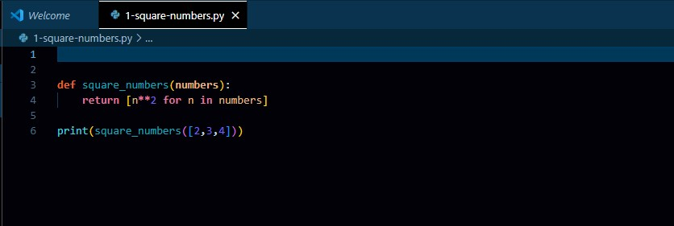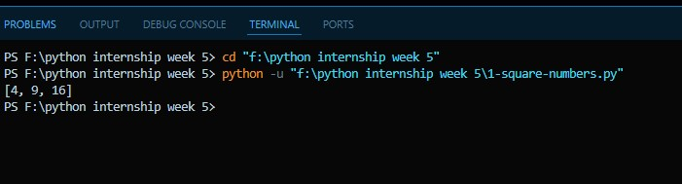

**Task 2 :**

Create a function `is_even_or_odd` that takes a number and returns whether it is even or odd.

**Solution:**

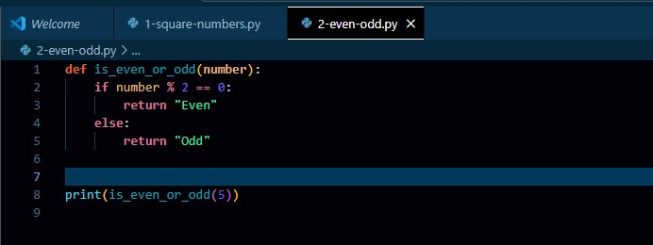

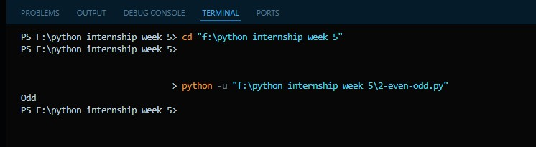

**Task 3:**

Write a function `calculate_area` that takes radius and returns area of a circle.

**Solution:**

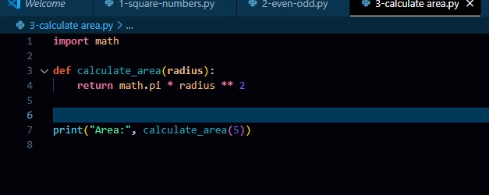

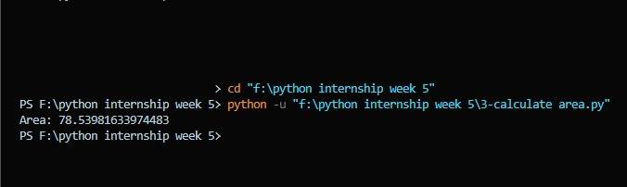

**Task 4:**

Write a function `greet_user(name, age)` that returns a greeting like: 'Hello Ali, you are 20 years old.'

**Solution:**

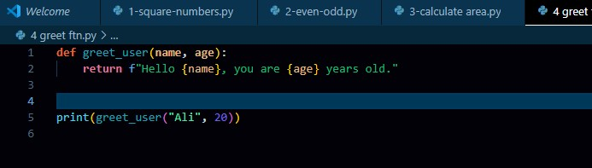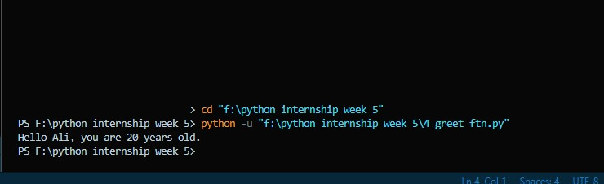

**Task 5:**

Create a function `change_counter()` that modifies a global counter variable.

**Solution:**

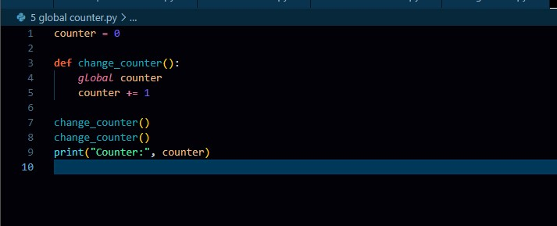

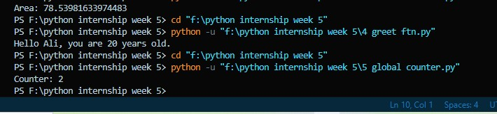

**Task 6:**

Create a module named `math_tools.py` with a function `multiply(x, y)` and use it in another script.

**Solution:**

